**4/4 Assignment #11 Final User Testing**

Lizz Corrigan | Maxine Dee | Steven Naisbitt | Kyle Carsey | Steve Langman

**Instructions**

The purpose of this assignment is to evaluate the overall effectiveness of the project. The team will recruit actual target learners (6-10) and ask the participants to learn the materials.

**User Development**

* **Instructions for User Testing  
  Link:** <https://drive.google.com/file/d/1PDsTv1Ilp9-qo_wkJ5M17haS6gkPIt6C/view?usp=sharing>

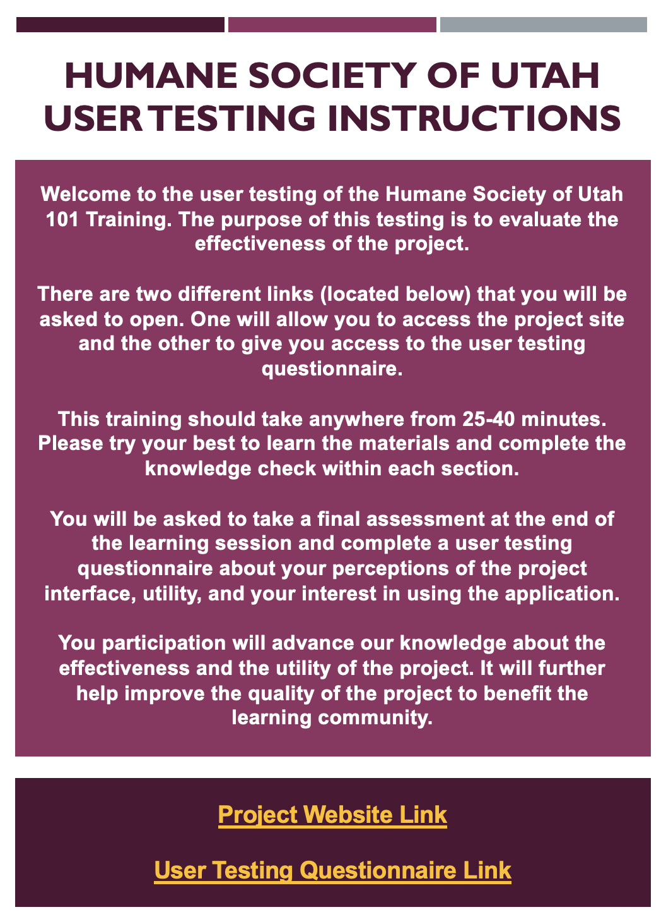

* **User Testing Instrumentation**
  + **Formative Assessment:** Knowledge checks (Multiple Choice, Yes/No, True/False, Scenario Based Questions, Short Answer) throughout the modules after each video. Each knowledge check has feedback based on the format of the questions.
  + **Summative Assessment:** Google Forms with Multiple Choice, True/False, Short Answer. The form automatically emails results to learners to verify that they have taken and passed the assessment. Feedback is given for each question set.   
    Summative Assessment Link: <https://forms.gle/CvGacv4f1ELNTgsKA>
* **User Testing Questionnaire:**Questionnaire Link: <https://forms.gle/jMqKetbudgCaSpSv5>

**Documentation**

* **Data collection:** collecting the data from formative, summative and questionnaire assessment. Organize the data and enter into the Excel.
  + We will be gathering data for the summative assessment and the questionnaire. However, we will not be recording data for formative assessment. We instead provide them with opportunities to correct their mistake after specific feedback is given.
  + We completed 12 user testings. Overall, users liked the interface of the training module and found it easy to understand.
    - **Excel Link for User Satisfaction Data and Summative Assessment Data:** <https://docs.google.com/spreadsheets/d/1sTxMF0BmGeUNbswA9GNbXwiFP04kxe8pSFbPM6-BDF4/edit?usp=sharing>
* **Data presentation:** Use visual data representation (e.g., pie chart, bar chart, etc.) to represent the outcomes
  + *See the next page for the bar graphs on our User Satisfaction Rating and Summative Assessment Data.*

